SQL QUERIES FOR PIZZA SALES ANALYSIS

1. KPI

1.Total Revenue

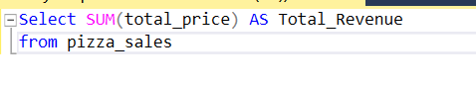

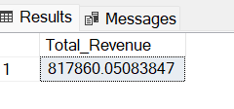

2.Avg Order Value



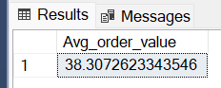

3.Total Pizzas Sold

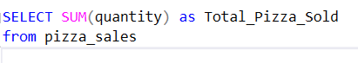

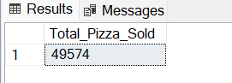

4.Total Order Placed

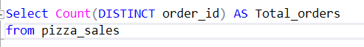

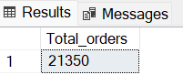

5.Average Pizzas Per Order

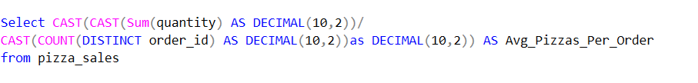

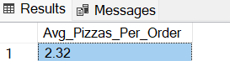

B.Chart Reqiurements

1.Daily Trend for orders



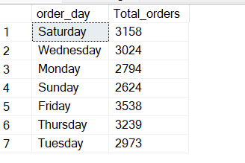

2.Monthly Trend for Orders



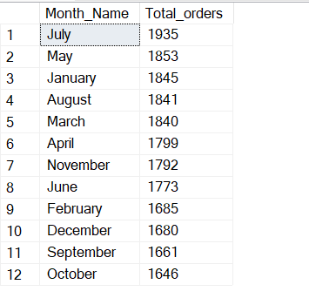

3.Percentage of Sales by Pizza Category

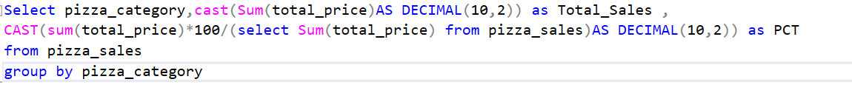

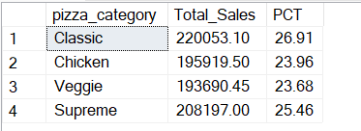

4.Percentage of Sales By Pizza Size

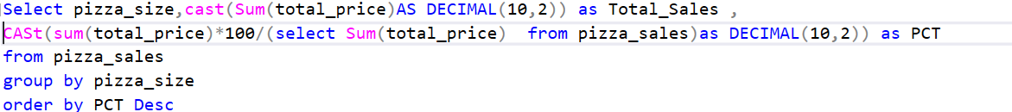

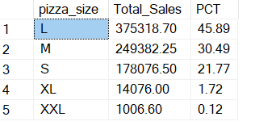

5.Top 5 Pizzas by Revenue



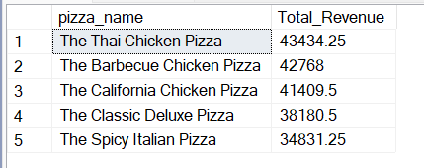

6.Bottom 5 Pizzas By Revenue

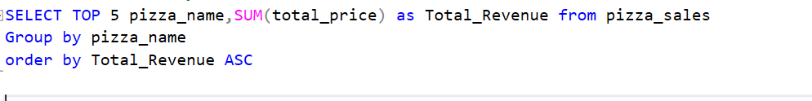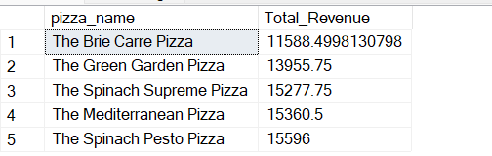

7.Top 5 Pizzas by Quantity

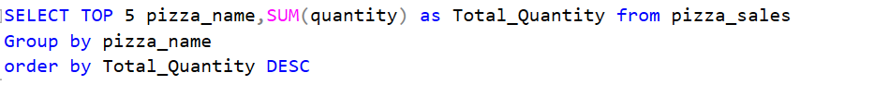

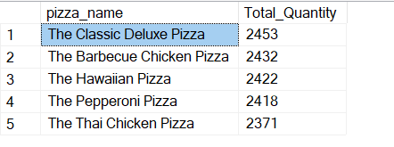

8.Bottom 5 Pizzas By quantity

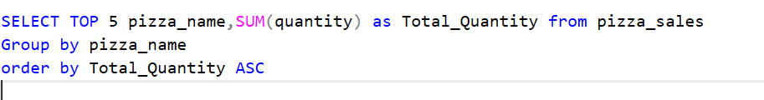

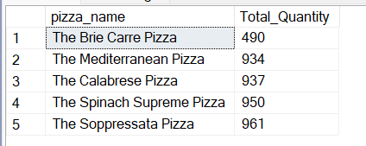

9.Top 5 Pizzas By Orders

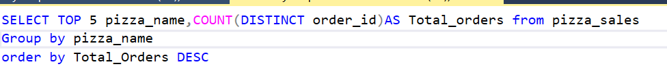

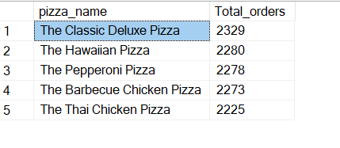

10.Bottom 5 Pizzas By Orders

